Sure! Here are examples for each method to get help in the Linux environment:

1. **Man Pages**:
2. man ls

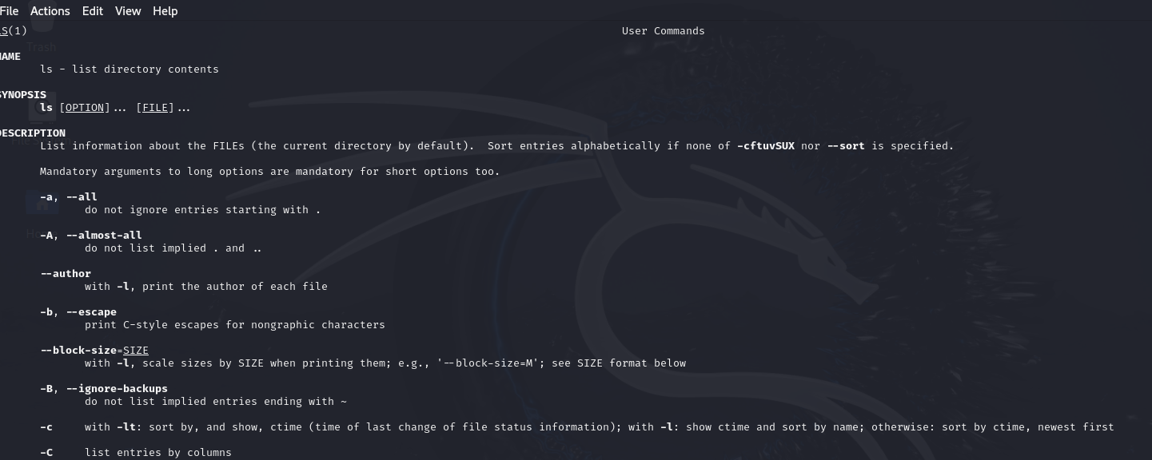

This command opens the manual page for the ls command, providing detailed information about its usage and options.

1. **Help Command**:
2. ls –help

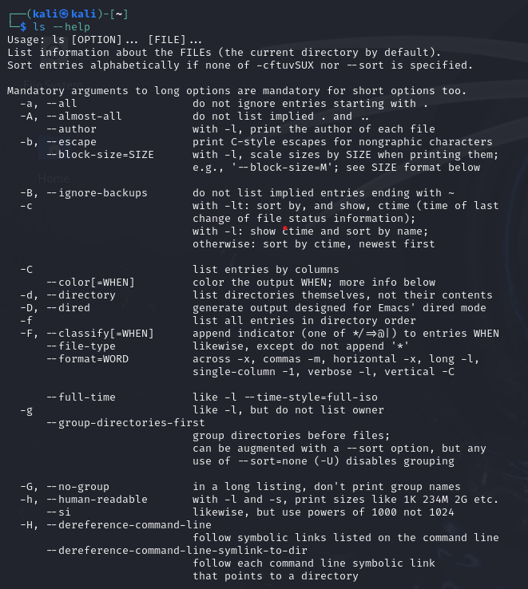

This command displays a brief overview of the ls command’s options and usage.

1. **Apropos Command**:
2. apropos copy

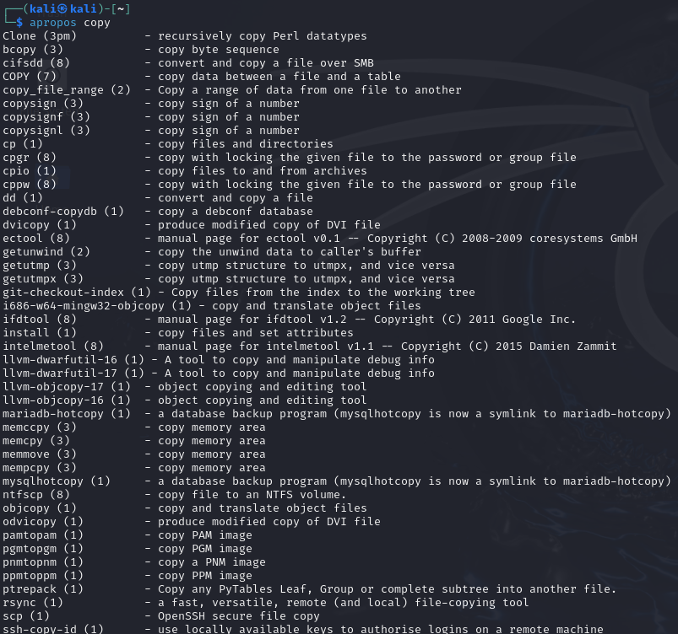

This command searches for commands related to copying files and lists them.

1. **Info Pages**:
2. info ls

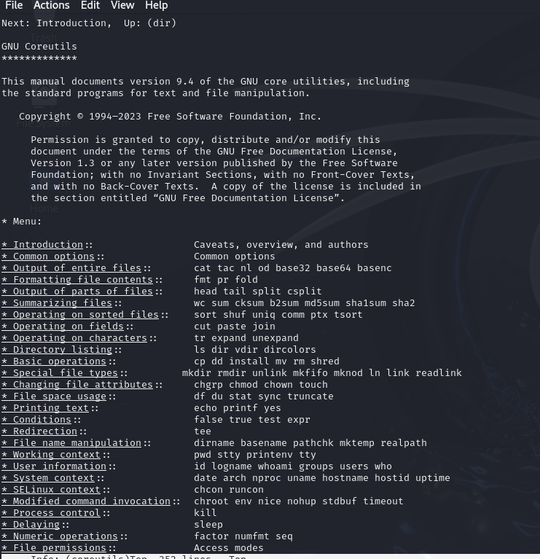

This command opens the info page for the ls command, offering more detailed documentation than the man page.

1. **Whatis Command**:
2. whatis ls

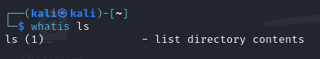

This command provides a one-line description of the ls command.

1. **Cheat Sheets**: You can find cheat sheets online, such as this one, which summarize common commands and their options.
2. **Online Resources**: Websites like Stack Overflow, Linux forums, and official documentation sites are excellent places to find help and ask questions.
3. **Built-in Documentation**: Some distributions come with built-in documentation accessible through commands like man, info, or help.